**`MAKERERE UNIVERSITY**

COLLEGE OF COMPUTING AND INFORMATION SCIENCES

SCHOOL OF COMPUTING AND INFORMATICS TECHNOLOGY

A REPORT ON

FIELD ATTACHMENT/ INTERNSHIP AT

SERVICE AND COMPUTER INDUSTRIES

JUNE 4th – JULY 28TH



BY

**ABILA RAPHAEL**

16/U/2673/PS

Field attachment report submitted to the School of Computing and Informatics Technology or College of Computing and Information Sciences

In Partial fulfillment of the requirements for the degree of Bachelors of Science in Computer Science of Makerere University Kampala

**ABILA RAHAEL** Sign ………………….

Field Supervisor.

**Eng. MIIRO WILLIAM**

Sign………………………… Stamp & Date ………………………...

Academic supervisor.

**Dr. AGNES NAKAWAWA**

Sign ………………………. Stamp & Date…………………………

**DECLARATION**

I, **Abila Raphael,** confirm that I have made clear facts and matters referred to in this report are within my own knowledge to be true. The opinions I have expressed represent my true and complete professional training at NCR services and computer industries. This report is original and has never been produced anywhere for any other degree award to any other university before.

Signed ………………….………...

Date …………/………/………….

**ACKNOWLEDGEMENTS**

My deepest gratitude is bestowed to the almighty God for availing to me the strength, guidance and might to go through this industrial training successfully. In this industrial training I have acquired so much experiences and skills as well as confidence boosting. Very many people have played important roles in making my training a success directly and indirectly, how grateful I am for what they have helped me accomplish.

My sincere appreciation goes to **SCI/NCR** for accepting me to train within their company through this on job training. With the exposure given to me, I experienced a lot of technical, engineering and personal activities for the betterment of my present and future career.

My sincere appreciation to the management of SCI/NCR for providing me the opportunity to acquire such a vast amount of knowledge. Special thanks go to **Mr. Kiggundu Kent** (Manager) who gives young people the opportunity to train at SCI/NCR to realize their dreams, **Engineer Miiro William** (Field Supervisor) whose supervision during this period has been with a lot of love, guidance and incomparable desire to see people learn new things and **Dr. Nakawawa Agnes** (School Supervisor) who entrusted me with guidance on how to learn on her visit to the company.

Vote of special thanks to all the staff members of SCI/NCR, the ATM team, the UPS team, the Xerox team and above all the Infrastructure and workshop team, the drivers who always took us to field not forgetting the individual engineers; Engineer Kagwa Apollo, Engineer Ssewankambo Godfrey, Engineer Kawuki Timothy, Engineer Kyambadde Michael, Chrispa, John, Derrick and Rashid for always providing assistance and guidance whenever need arose.

Finally I would like to thank my parents for the financial support I got from them during my training and also my fellow trainees; Apolot Mercy, Nakitto Saubah, Nakakande Catherine, Nantege Jane,, Awikireze Bridget, Nakayiwa RoseMary, Wasswa Peter, Luyombya Pius, Nanyonjo Jacky, Aboula Marlin Nyanzi Esther, Nalubega Cissy, Zawedde Alice, Agwa Daniel, Najjeke Rahmah and Mumbere Joel for their cooperation and support rendered to me during my training and the family they became during my time at SCI/NCR.

**ABSTRACT**

This report is about the industrial training I carried out at NCR/ Service and Computer Industries (U) Limited between 4th JUNE to 28th JULY 2018. It is an expectation of the Department of Computer Science that students pursuing a degree in computer science must undergo this training aimed at gaining hands-on skills and experience before completing studies at the University. This report gives an overview of the benefits I fetched from training, the background of the organization, vision and mission of the organization, challenges faced, purpose of the training and the objectives of the organization to mention but a few.

At the training field, I was trained in various fields like CSD (Customer Service Department) Computer repair and maintenance, Infrastructure, and UPS in CSD, Cabling and Networking in CSD and Software installation among others.

In the field we carried out repair on different devices like laptops, desktop computers, UPS’s, printer etc. We also set up and configured hardware like personal computers, routers, servers and also configured IP addresses of clients and also installed biometric devices and configured them as well. Whatever was discussed and covered is well explained and detailed in this report.

Table of Contents

[ABBREVIATIONS/ACRONYMS viii](#_Toc521083879)

[CHAPTER ONE 1](#_Toc521083880)

[1.1 INTRODUCTION 1](#_Toc521083881)

[1.2 ORGANIZATION CHART 2](#_Toc521083882)

[1.3 NCR BACKGROUND 3](#_Toc521083883)

[1.4 MISSION 3](#_Toc521083884)

[1.5 VISSION 3](#_Toc521083885)

[1.6 VALUES 4](#_Toc521083886)

[1.7 IT ENGAGEMENT ACTIVITIES 4](#_Toc521083887)

[CHAPTER TWO 5](#_Toc521083888)

[2.0 FIELD ATTACHMENT ACTIVITIES. 5](#_Toc521083889)

[2.1 CSD COMPUTERS AND PERIPHERALS DEPARTMENT. 5](#_Toc521083890)

[**2.1.1 PCs** 5](#_Toc521083892)

[**2.1.2 PROJECTORS.** 6](#_Toc521083893)

[**2.1.3 ATM.** 9](#_Toc521083894)

[**2.1.4 POS (POINT OF SALE)** 11](#_Toc521083895)

[**2.1.5** **BIOMETRIC INSTALLATION** 15](#_Toc521083896)

[**2.1.6 PREVENTIVE MAINTENANCE (PM)** 17](#_Toc521083897)

[2.2 NETWORK INFRASTRUCTURE DEPARTMENT. 19](#_Toc521083898)

[**2.2.1 CABLED NETWORKS** 19](#_Toc521083899)

[**2.2.2 WIRELESS NETWORKS** 29](#_Toc521083900)

[2.3 CSD UPS DEPARTMENT. 32](#_Toc521083901)

[**2.3.1 UPS TOPOLOGY.** 32](#_Toc521083902)

[**2.3.2 UPS TYPES.** 32](#_Toc521083903)

[**2.3.3 UPS BYPASS MODE.** 34](#_Toc521083904)

[2.4 ESD DEPARTMENT. 35](#_Toc521083905)

[**2.4.1 SERVERS** 35](#_Toc521083906)

[**2.4.2 NOTIFIER APP** 36](#_Toc521083907)

[CHAPTER THREE. 37](#_Toc521083908)

[3.0 DISCUSSION OF EXPERIENCES 38](#_Toc521083909)

[3.1 Knowledge and skills gained 38](#_Toc521083910)

[3.2 Most interesting experiences. 38](#_Toc521083911)

[3.3 Relatedness of University’s taught programs to field of work. 38](#_Toc521083912)

[3.4 Challenges faced and how managed. 39](#_Toc521083913)

[3.5 Benefits derived from field attachment. 39](#_Toc521083914)

[3.6 Career motivation. 40](#_Toc521083915)

[CHAPTER FOUR 41](#_Toc521083916)

[4.1 CONCLUSIONS. 41](#_Toc521083917)

[4.2 RECOMMENDATIONS. 41](#_Toc521083918)

[4.3 APPENDICES. 42](#_Toc521083919)

## 

[Figure 1- Company structure 2](#_Toc521086334)

[Figure 2- PC internal structure 5](file:///C:\Users\ARTHUR\Desktop\RAPHAEL\reports\individual.docx#_Toc521086335)

[Figure 3- ATM transfer belts 10](file:///C:\Users\ARTHUR\Desktop\RAPHAEL\reports\individual.docx#_Toc521086336)

[Figure 4- ATM cassettes. 10](#_Toc521086337)

[Figure 5- POS setup 11](file:///C:\Users\ARTHUR\Desktop\RAPHAEL\reports\individual.docx#_Toc521086338)

[Figure 6- POS pole display 12](file:///C:\Users\ARTHUR\Desktop\RAPHAEL\reports\individual.docx#_Toc521086339)

[Figure 7- POS monitors 12](file:///C:\Users\ARTHUR\Desktop\RAPHAEL\reports\individual.docx#_Toc521086340)

[Figure 8- POS handheld scanner 13](file:///C:\Users\ARTHUR\Desktop\RAPHAEL\reports\individual.docx#_Toc521086341)

[Figure 9- POS table scanner 13](file:///C:\Users\ARTHUR\Desktop\RAPHAEL\reports\individual.docx#_Toc521086342)

[Figure 10- cash drawer. 14](file:///C:\Users\ARTHUR\Desktop\RAPHAEL\reports\individual.docx#_Toc521086343)

[Figure 11- Receipt printer. 14](#_Toc521086344)

[Figure 12- POS PC 15](file:///C:\Users\ARTHUR\Desktop\RAPHAEL\reports\individual.docx#_Toc521086345)

[Figure 13- Biometric devices 16](#_Toc521086346)

[Figure 14- Twisted pair cable 21](#_Toc521086347)

[Figure 15- Shielded twisted pair cables 22](#_Toc521086348)

[Figure 16- Coaxial cable 22](#_Toc521086349)

[Figure 17- Patch cables. 23](#_Toc521086350)

[Figure 18- Straight through termination 23](#_Toc521086351)

[Figure 19- Cross over termination 24](#_Toc521086352)

[Figure 20- Optic Fibres. 25](#_Toc521086353)

[Figure 21- Packet Tracer configuration 29](#_Toc521086354)

[Figure 22- Access point layout. 30](file:///C:\Users\ARTHUR\Desktop\RAPHAEL\reports\individual.docx#_Toc521086355)

[Figure 23- Bridge layout. 30](file:///C:\Users\ARTHUR\Desktop\RAPHAEL\reports\individual.docx#_Toc521086356)

[Figure 24- WDS setup. 31](file:///C:\Users\ARTHUR\Desktop\RAPHAEL\reports\individual.docx#_Toc521086357)

[Figure 25- UPS topology 32](#_Toc521086358)

[Figure 26- Stabilizer. 33](#_Toc521086359)

[Figure 27- Before and after UPS installation 34](#_Toc521086360)

[Figure 28- UPS Bypass structure. 35](file:///C:\Users\ARTHUR\Desktop\RAPHAEL\reports\individual.docx#_Toc521086361)

[Figure 29- Internal structure of a server 36](#_Toc521086362)

[Figure 30- Interfaces of Task Notifier App. 37](file:///C:\Users\ARTHUR\Desktop\RAPHAEL\reports\individual.docx#_Toc521086363)

[Figure 31- Cable laying at Makerere, card printer, industrial cable. 42](file:///C:\Users\ARTHUR\Desktop\RAPHAEL\reports\individual.docx#_Toc521086364)

[Table 1- Showing Company IT solutions. 1](#_Toc521142933)

[Table 2- Showing Projector components 7](#_Toc521142934)

[Table 3- Showing biometric installation requirements. 16](#_Toc521142935)

[Table 4- Preventive Maintenance equipment. 18](#_Toc521142936)

[Table 5- Cable termination tools. 27](#_Toc521142937)

**ABBREVIATIONS/ACRONYMS.**

NCR National Cash Register.

SCI Service and Computer Industries

SATA Serial Advancement Technology Attachment.

HDD Hard Dick Driver.

LAN Local Area Network.

UTP Unshielded Twisted Pair

UPS Uninterrupted Power Supply

CPU Central Processing Unit

HDMI Higher Definition Multimedia Interface

Config Configuration

IDE Integrated Digital Electronics

P.C Personalized Computer

POS Point of Sale

AC Alternating Current

MD Managing Director

ED Executive Director

CSD Customer Service Department

IT Information Technology

RAM Random Access Memory

ESD Enterprise Support Department

ATM Automated Teller Report

# 

# CHAPTER ONE

## 1.1 INTRODUCTION

Industrial training is an engagement activity in which students participate to gain knowledge, experience hands-on skills, and be exposed in the fields of their profession; and is scheduled for a specific period of time. Students get to appreciate what entails the IT field and get exposed to organizations and people who are potential future employers. This training is expected to equip students with knowledge and practical experiences to enable them handle and solve several computer problems in this technology era and also to acquire the social skills which will facilitate them to fit in the work place.

Industrial training in this perspective was carried out at service and computer industries limited (NCR). This organization offers complete end-to-end solutions from conceptualization to implementation to maintenance. It also offers a wide range of products and services, and it's certified and well trained personnel making it one stops choice for IT solutions. Below is a table showing a summary of the solutions they offer:

|  |  |  |
| --- | --- | --- |
|  | **Products and services** | **Device brand** |
| **Solutions** |
|  |  |  |
| Automated banking | ATM, support, POS | NCR |
|  |  |  |
| Networking | Design and implement networks, maintenance and support, security. | Cisco, D-Link, Brand Rex,  3com, Avaya, Lucent |
|  | Server support and Maintenance, sales and repairs | Dell, NCR, IBM, HP, Compaq,  Toshiba, Acer |
| Computers(PCs, servers, desktops, Notebooks) |
|  | Sales, POS and installation. | Spice mobile, Philips, Panasonic and Cisco IP Phones |
| Voice |
|  |  |  |
| Office Automation | Photocopiers, Scanners,  Printers Support and maintenance | Tally, Genicom, Epson,  Olivetti |
|  | Sales, UPS installation, support and maintenance | EATON, APC, Invensys  Power Systems |
| Power solutions |
|  | Storage, Installation and  Support | Blick SA, Dell |
| Enterprise Solutions(Tape drives, software firewalls) |

Table 1- Showing Company IT solutions.

## 1.2 ORGANIZATION CHART

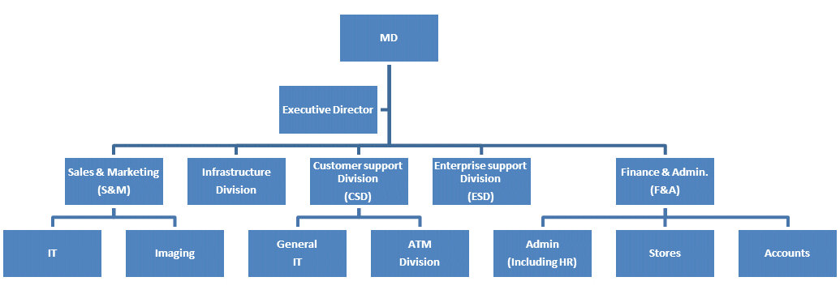

Figure 1- Company structure

**Employer Profile.**

Managing director(MD) –The overall controller of the company

Executive director(ED)-The head of departments

Sales and marketing -Supervises the IT depart and imaging

Customer support Division-Deals in automated teller machines (ATMs)

Finances and administration –Manages Accounts and stores

## 1.3 NCR BACKGROUND

NCR in Uganda was established in 1962 but Service & Computer Industries took over the operations later; in 1989. Even today Service & Computer Industries is often referred to as NCR owing to the commitment and dedication with which it has continued to represent the NCR range of products and services.

Service & Computer Industries (NCR) is the sole distributor of NCR, D-Link, Ingenico,

Power ware, Systimax, Avanza, EDS, and Cybernett in Uganda. The company has formed strategic alliances with Dell as Master Distributor, Cisco as Premier Partner, Microsoft as Certified Partner, Olivetti, Zebra, Tally Genicom, and Hewlett Packard.

These alliances have ensured a strong support network and backup solutions to its IT clients. SCI occupies the biggest market share of Automated Teller Machines and is recognized as the largest Dell representative in the country. It consists of over 45 engineers, trained by the very best in their fields and five service centers spread throughout the length and breadth of the Country.

It was declared an ISO9000 certified company on April 2001 and is Customer-focused and Employee-centered.

Quality, integrity and reliability are key words in the Service & Computer Industry family. SCI is the leading provider of IT solutions in Uganda today. It brands it's self as a versatile

IT solutions organization and has provided most IT solutions to many different companies. There solutions range from hardware, software, educational, training, repairs, service and maintenance and network, installations, and sales.

## 1.4 MISSION

SCI is committed to provide the most effective and complete solutions conforming to international standards in information technology sector for organizations and individuals and to be the leading IT firm in East Africa

To create and provide sustainable ICT solutions that meet customers’ satisfaction

## 1.5 VISSION

To be the undisputed market leader in provision of ICT solutions and services

## 1.6 VALUES

Integrity, Teamwork, Customer focus, Flexibility, Empathy, Innovativeness, Timeliness.

**Commitment.**

SCI is committed to satisfy every customer’s need by implementing and maintaining good customer relationships and well defined quality systems which as well address the needs of employees, shareholders and other stakeholders.

## 1.7 IT ENGAGEMENT ACTIVITIES

NCR consists of four departments in which trainees are exposed for training, they include: **Enterprise solutions** department deals with complex systems such as servers; offers data storage services and software solutions. It also offers networking services and also deal with network devices such as routers, switch, IPhone, their setups, configurations and maintenance.

**Cabling and Networking** department; this handles building of network infrastructure, designs and implementation of these designs to come-up with a systems capable of high-speed data access, redundancy, failover resistance, and security.

**PCs and printers.** this department deals with troubleshooting, installing and configuring software of UPS, help desk support, service and maintenance, and device repairs, such devices include; PCs, all kinds of printers, UPS, ATMs and servers.

**Workshop and UPS.** Here trainees are exposed to all kind of UPS. It also deals with setting up of UPSs and their network monitoring, maintenance and servicing

# CHAPTER TWO

# **2.0 FIELD ATTACHMENT ACTIVITIES**.

During my training, I was able to undergo training in four different departments in the company since a time table of accessing the departments was given to me on my first day, and through this, I have assisted the Organization by performing the assigned duties such as being sent to field with company engineers to handle several customer complaints in different field of Information technology. Below are the activities I carried out under each department.

## **2.1 CSD COMPUTERS AND PERIPHERALS** DEPARTMENT.

CSD department basically comprises of the workshop where client’s devices such as tabs, printers, projectors, PCs, monitors and so many others are repaired. It’s in this department that all the repairs are done and it contains a store as well that is used for keeping these devices brought to the company by different customers. This was the first department that I started my training from and was able to learn and perform the following tasks.

### **2.1.1 PCs**

My first encounter with a PC was when we received a client’s machine in the workshop that needed replacement of a new motherboard. For one to be able to replace a board, he or she has to open the whole system and this helped me learn the different components of the PC with the help of Eng. Apollo. Below is a structure of a PC.

Figure 2- PC internal structure

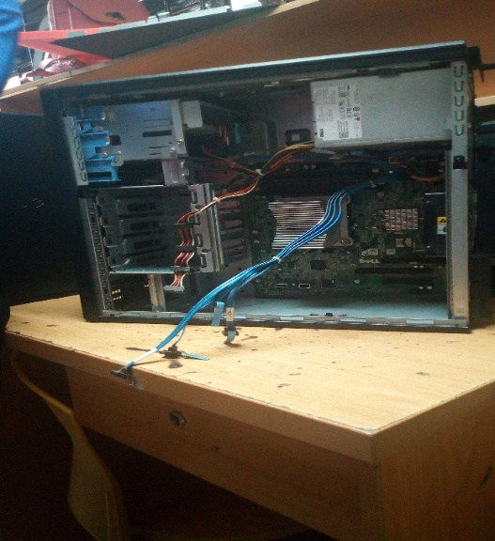

**Functions of PC components.**

**Motherboard** – it is a printed circuit board that wires all the other parts together.

**Power supply** – Converts AC to low voltage DC current and supplies it to the board.

**RAM chips** – Acts as an instant memory module to the computer.

**Hard Drive** – Part of the computer that stores information.

**Heat sink** – Incorporates either a fan or some other component to keep a warm component cool.

**System fan** – provides a cooling system for the PC.

**Processor**  – It is responsible for interpreting every code it receives from other components.

### **2.1.2 PROJECTORS.**

Through interactions with quite a number of engineers like Eng. Apollo, Eng. Kerunga in the workshop, I was able to understand projectors in detail that is to say projectors are referred to as electronic devices that are used to display large images on a white screen or back ground and there are basically three types of projectors which include;

* LCD -Liquid Crystal Display projectors.
* DLP -Digital Light Processing projectors.
* LED -Light Emitting Diode projectors.

These projectors are usually small in size which makes it fairly portable. It has a lamp that produces minimal amount of heat and there is no need of replacing the lamp.

Generally, these projectors were named according to their modes of display for example DLP projectors use trans missive mode of display unlike LCD projectors which possess a reflective mode of display just like how their names speak. These projectors are different in terms of their features for instance some DLP input can be accessed with an Ethernet cable which may not be the same for other projector types.

**GENERAL COMPONENTS OR PARTS OF A PROJECTOR.**

|  |  |
| --- | --- |
| **Logic board** | **Colour wheel** |
|  |  |
| **DMD Chip Dichroic Micro Device** | |
|  |  |
| **Standard Lamp** | **lens system** |
|  |  |

Table 2- Showing Projector components

**Mode of projector operation.**

* Power the machine
* Current moves to the power supply
* Ballast module converts the power /powers the lamp
* When the lamp is powered it produces a beam of strong light that enables the image to be displayed on the screen
* From the lamp the beam of light strikes the color wheel (circular mirror) which mix the colors, when its combined it comes out with three primary colors.
* The remote sensor senses the remote
* The Logic board controls logic functions for decision making
* Lens system for forecasting the image
* DMD chip made up of tinny microscopic mirrors which keep on moving as a beam of light strikes it (each mirror is 5th to the size of 1hair)

**Factors to consider when buying a projector.**

* Lamp hours
* Resolution of a projector is measured in lumens(units)
* Consider the display, how white
* Heat, heat from the projector LED doesn’t emit heat because it has heat sinks
* Size
* LCD have efficient light and have more lumens
* LCD have dust filters, LED and DLP need a well aerated environment
* LCD have more lenses than DLP
* Prisms and the lenses are so delicate

**Problem with projectors.**

* Lamp failure
* Dotted display
* Horizontal and vertical lines in the display
* Power issues
* Noise making when they get errors they have light displaying beeps
* Heat sensor
* A lot of heat
* Abrupt shut down
* Lamp might be faulty or reaching the end of its life time.

### **2.1.3 ATM.**

An ATM is simply a data terminal with two input and four output devices. Like any other data terminal, the ATM has to connect to, and communicate through, a host processor.

The host processor is connected to an Internet Service Provider using either dial-up or a leased line; which is the gateway through which all the various ATM networks become available to the cardholder.

Leased line machines connect directly to the host processor through a four-wire, point-to point, and dedicated telephone line. Dial-up ATMs connect to the host processor through a normal phone line using a modem and a toll free number, or through an Internet Service Provider using a local access number via a modem.

**Types of ATM.**

* NCR ATM’s like personal, self-serve ATM’s.
* Winko ATM’s.

**Parts of ATM**

* Pc Core – Stores configurations.
* Monitor ­– Which is the plat form for programming and interfering with the core.
* Journal printer- Records whatever takes place in the ATM.
* Card reader- decodes information on the ATM card of a customer.
* Receipt printer- this prints a receipt for the client after use of the ATM.
* Cash dispenser- this gives out cash during the withdraw process.
* Cash accept- this gives out cash during the withdraw process.
* Envelop deposit room – this gives out an envelope during the deposit process.

**Structure of an ATM**

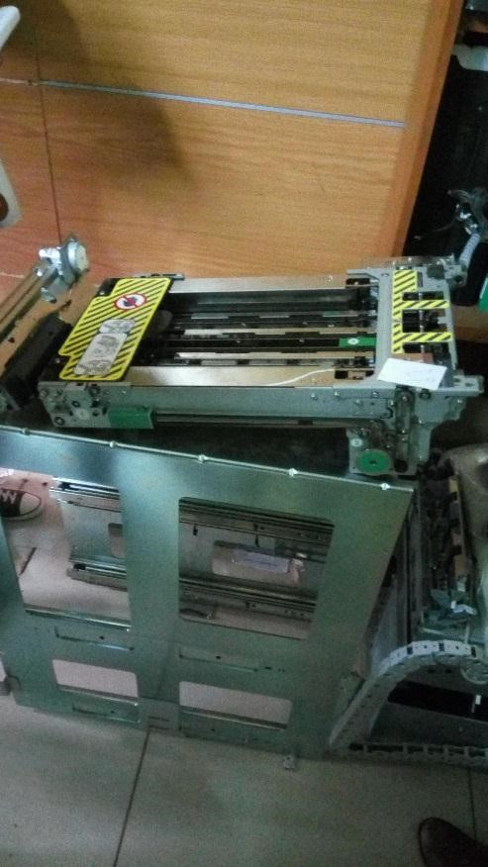

Figure 3- ATM transfer belts

Figure 4- ATM cassettes.

**Modes of operation.**

* Insert ATM card for decoding process, the user the display monitor to choose the kind of transaction you want to do.
* If its withdraw process the cash dispenser will give out money to the client.
* But if it’s a deposit process the cash acceptor will lead the envelop deposit room to give out an envelope for the client to put the money, then it will finally request for the envelop back which accepting the money.
* The through the stacker the vacuum will suck the money for storage.

**Problems**

* Dust
* Loose belts on the cash dispenser and acceptor.
* Rodents eating up the belts and the wire interconnecting the components.
* Power problems.
* Earthling problems.

**Trouble shooting.**

* Keep in a cool dry place to avoid overheating.
* Keep in a clean place for rodent prevention.
* Install electric shock absorbers.
* Power problems should be rectified before powering the ATM.

### **2.1.4 POS (POINT OF SALE)**

This is a time and place where a retail transaction is completed. Or It’s where sales are made. It can also be a combination of software and hard ware that allows merchants to take transactions and simplify key day –to cash flows (computerized replacement for a cash register). POS is usually installed in super markets, pharmacies, restaurants, and some shops simply because it reduces chances of theft since it ensures easy accountability. Its structure is also connected in the format below;

**Illustration**

Monitor

Printer

Cash Drawer

Customer

Display

PC

Scanner

Figure 5- POS setup

**PROCESS OF BUYING AN ITEM**

* Pick items from the shop/supermarket or restaurant
* Present it the item to the cashier on the counter.
* He or She scans the items and amount
* The customer display, displays how much a customer is supposed to pay and he or she makes the payment.
* Cashier inputs the amount into the system and the printer prints out the receipt.
* The cash drawer opens for the money to be put and get the balance if any.
* The customer display then indicates the next customer after completion of the transaction.

**FUNCTIONS OF EACH COMPONENT OF A POS SYSTEM**

1. **Pole display device** –This device enables to display the money needed to be paid by the customer hence the customer cannot complain since they see the money to pay one the display device, its connected to the pc, this is all at the checkout point.



Figure 6- POS pole display

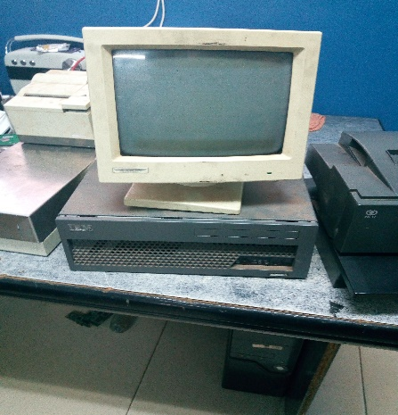2. **PC** (**keyboard, POS monitor, keyboard**) –This device helps to control the system, the monitor displays to the casher what he or she is inputting using scanner and the system enables easy data transaction from the till or sales point to the server room or back office.

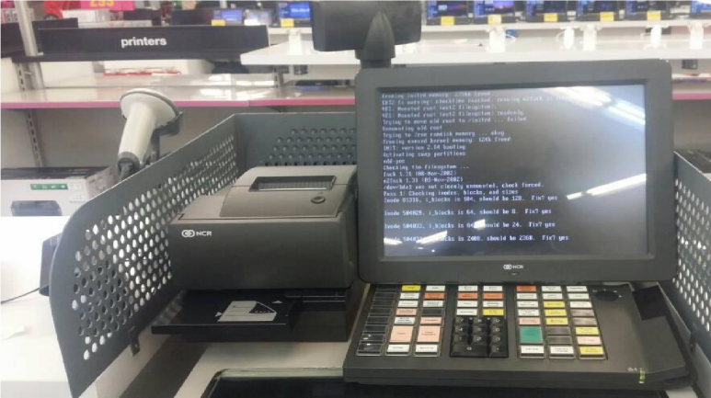

Figure 7- POS monitors

3. **Scanners** - The **hand-held** **scanner** enables to read bar codes on the item, which every barcode has embedded information in it, this enables proper monitoring of stock being taken out at the checkout point. Stock take device, its connected to the server indirectly, its used to enter stock that is brought in to the system.

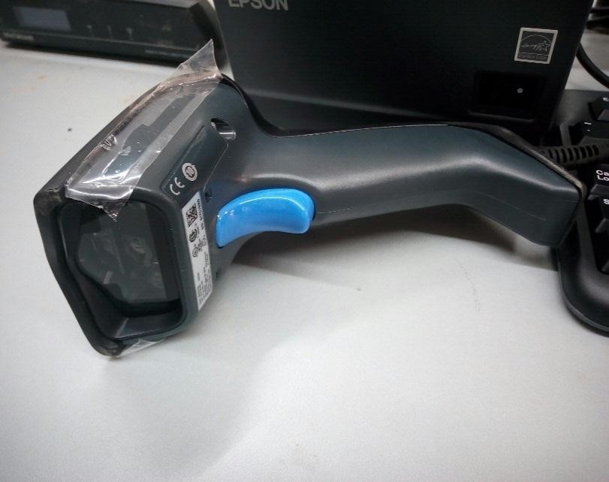

Figure 8- POS handheld scanner

-The **table scanner** is usually used to scan bar codes on items moving out of the supermarket or shop.

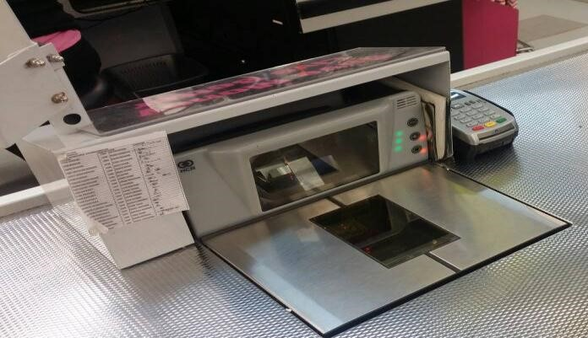

Figure 9- POS table scanner

4. **Crone’s clock**- It is connected to the database and the server, it captures the time or monitors the time during the transaction process

5. **Cash drawer-** It is used for money transactions. The cash drawer cannot open unless a transaction is being made and this is done when a receipt is printed from the receipt printer.

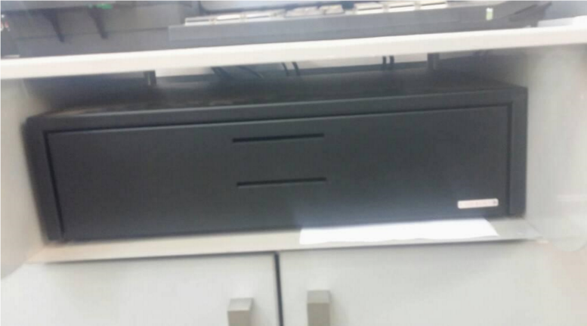

Figure 10- cash drawer.

6. **Receipt printer** –It is connected to the pc and it’s for printing receipts for customers during the transaction at the check point.

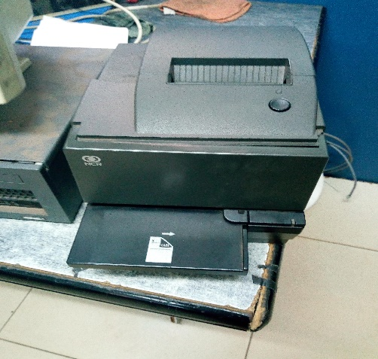

Figure 11- Receipt printer.

7. **PC**- This is where almost all components of a POS system are connected except the cash drawer

that is connected to the printer. Below is an NCR model 7601 PC.

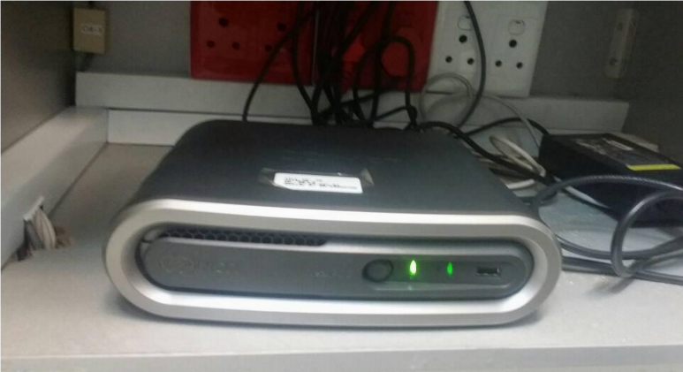

Figure 12- POS PC

### **BIOMETRIC INSTALLATION**

Biometrics simply refers to conversion of human traits into measurements, for instance finger prints are converted into a unique series of digits and stored as a metric. There are two major types of biometrics;

1. **Biometric access control.** This is used to control access to any authorized persons and majorly applied in organizations such as banks, server rooms, hospital theatre among others.
2. **Biometric time and attendance system**. Basically used to monitor employees working patterns, in most cases it is migrated with the human resource pay roll systems**.**

**BIOMETRIC MODES**

**Finger prints:** One’spersonal finger trait is enrolled into the system for attendance monitoring.

**Retinal Iris:** Access is grated when you put an eye into the system.

**Card Swipe:** Here one uses a card to access a room by swiping it on the machine.

**PIN:** Authorized persons are given a pin to use for granting access.

**Body Access:** Requires the entire body to access, missing body parts denies one access.

**FAILURES OF AUTHENTICATION FOR FINGER PRINTS.**

* Poor placement of the fingers into the machine
* Fingers covered with impurities such as Greece, varseline.
* Extremely dry fingers.
* Faulty devices.

**BIOMETRIC DEVICES**.

There are basically two types of biometric devices;

1. **ZKTECO.** This is of type F18 only.
2. **SUPREMA.** This uses a software called Bio star which supports a variety of versions such as V1.8 which comprises of Biostaton and Xpass.

These devices can either be indoor or outdoor since the outdoor devices are designed in such a way that they are robust to harsh weather. Installation requires the following;

|  |  |
| --- | --- |
| Time and Access Biometrics. | Access Control Biometrics. |
| Bio device and a server.  Ethernet or LAN connection  Power adapter or power supply  Software; licensed or not | Exit button  Magnetic lock  Emergency button  Plus all that is needed to install a Time and Access |

Table 3- Showing biometric installation requirements.

My group and I managed to install an Access Control Biometric under the instruction of Eng. Sewamkambo

and below are some of the devices that we used for the installation; card swipe, finger print machines and magnetic lock.

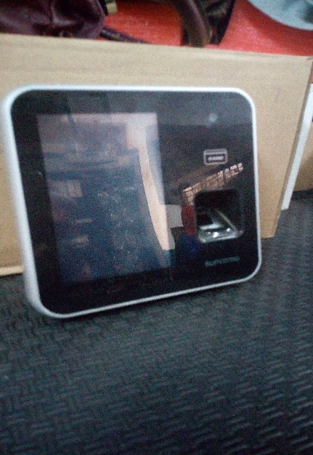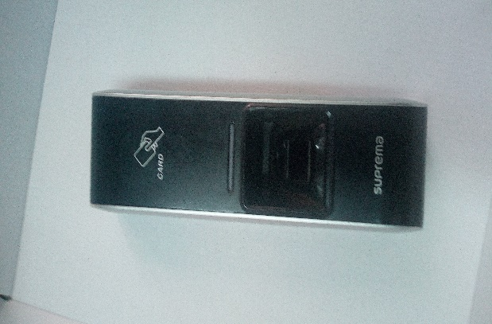 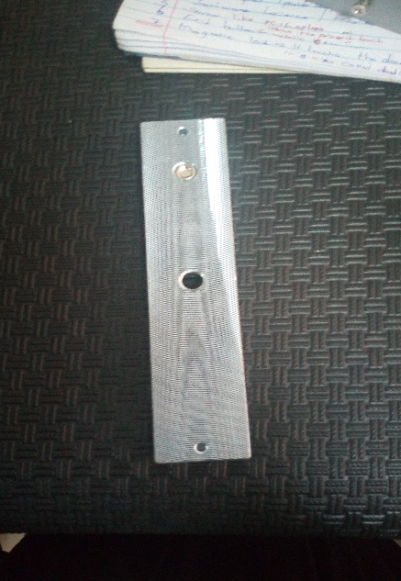

Figure 13- Biometric devices

### **2.1.6 PREVENTIVE MAINTENANCE (PM)**

Preventive maintenance refers to wiping and blowing dust from electronic devices i.e. PCs, Printers, Scanners, ATMs, UPS, Laptops, Projectors and server and ensuring a normal computing environment which may have effects such as holding heat, humidity which is horrific and awful for electronics, For PCs, PM goes beyond the hardware cleaning ie it also involves software clean up like deleting temporary files, performing disk clean up.

The company usually carries out preventative maintenance every Saturday for the customers who confirm and make orders. Clients are always advised to carry out a PM Service frequently in a period of three to four months (3 – 4 months). During the training I went for several preventive maintenance activities like at Standard chartered Kireka, KPMG, ICEA and we were able to use a variety of equipment when carrying out the PM services;

* A blower to thoroughly blow all the dust from the machine. One has to be careful when using blower because there are parts that are not blown directly like the system fans, processor and boards which are to blown from a distance.
* A detergent like pledge or vim poured on a clean and dry piece of cloth to whip the machine to remove dirt. Vim is usually used to scrub white surfaces while pledge is used on sticky materials on surfaces.
* Screw drivers to open up the machine so as to clean some of the inner components that the blower can’t reach.
* Gloves can also be used for protection from really dirty surfaces.
* Towels, these are of two different types, one is rough and is used for scrubbing surfaces after applying a detergent like pledge but it usually leaves small particles after cleaning and the other smoother towel is used to wipe away all those particles to make the surfaces look neat.

Below are some of the equipment used during a PM service.

|  |  |
| --- | --- |
| Pledge | Towel |
| **G:\intern photos\IMG_20180727_082824.jpg** | G:\intern photos\IMG_20180727_083016.jpg |
| Blower | Shinex |
|  | G:\intern photos\IMG_20180727_082927.jpg |

Table 4- Preventive Maintenance equipment.

**STEPS TO CARRY OUT A PREVENTIVE MAINTENANCE SERVICE**.

* Test the device: This is the initial step to carrying out a PM where an engineer should ensure that he knows the state of the machine he is working on and if possible, one should have evidence like photos of the machine state, this prevents false claims by the client after working on their machines.
* Turn off the machine.
* Wait for the machine to cool.
* Connect the blower to power.
* Blow out all the dust through all the holes or openings on the device like monitors, PC.
* Do thorough cleaning of the machine using detergents, hard brush and towels.
* Reconnect the machine how you found it and restart.
* Perform a software Test

-Run system diagnostics using the F12 and F5 for DELL machines.

-Reboot the machine back to Windows.

-Ask for password if any and perform a Disk clean up by typing ‘cleanmgr’ and ‘%temp%’ to clear temporary files after defragmentation.

* After all this is done, hand over the machine to the client.

## 2.2 NETWORK INFRASTRUCTURE DEPARTMENT.

This department deals with bringing up the physical network infrastructure at a customer’s site before the computer hardware is put in place and the logical network set.

This department deals with both **cabled networks** and **wireless networks** and for this training we were able to handle both of them with quite a number of engineers like Eng. Sewamkambo, Eng. Kiguli and some other colleagues of mine like Joel, Rose Mary. Below are the activities that were carried out in this department when handling;

### **2.2.1 CABLED NETWORKS**

This involves the physical laying down of cables and has a variety of steps to follow.

1. **Site survey**

Before a cabled network is built, there are important aspects that must be put into considerations and they include the following:

Inspecting the site or the existing network infrastructure to find out the requirements needed such as the size of the network, the number of network clients to be implemented, broadband speed required, the number and type of equipment to use, telecommunication pathways and the nature of the site the next procedure is to come up with the architecture of the site and plan a network design.

1. For example, we went for site survey at Makerere University at the school of Computing, Block A for setting up network system /structure for their work shop room on level one. Carried out measurements using tape measure and the next day we made cable installations.
2. Fixed 38mm by 25mm trunking onto the walls to conceal cables
3. Made measurements for data cables and used conduits to pass data cables through the walls (conduits protect cables from radians like rats which could damage the cables)
4. Connected the data cable from the workshop room to the back office also called the server room. Here, terminations were carried out using standard B.
5. Installed rack cabinet using different tools like a drilling machine, strippers, crimping tool for cutting cables. Next to but connected to the rack cabinet, was a D-Link router that enables wireless access and wide area network, the LAN (local area network) is connected through the switch.
6. Information outlet points were set up in the middle of the room below the conference table so that clients/users could easily access them including power cables supplying DC current. This involved drilling the tiles on the floor to lay down the cables which were later covered by metallic conduits.
7. **Network Design:**

Network design considerations are tackled at this stage and may include; the passage of the telecommunication pathways, location of the equipment room and information outlets. An equipment room is a central space used to house telecommunications equipment intended to service users throughout the entire network. Telecommunication closet is a space that supports the cable and the equipment necessary for transmission between the building's backbone and information outlets. They fall into three major categories:

**Underbuilding distribution system**; these cater for communication connections outside the building. Intra-building backbone; these are used between the equipment room and the telecommunication closets. They must support any type of telecommunication media serving the equipment.

**Horizontal cabling;** these are implemented between the telecommunication closet and the information outlets. The commonly preferred horizontal distribution method is a flexible cable tray in conjunction with plenum cable in a false ceiling.

**Depending** on the **customers’ needs,** a suitable communication media must be determined and implemented. This can be data, voice and/or video.

**Transmission media**

A cable is the medium through which information usually moves from one network device to another. Basically; different networks can use a variety of cable types. The type of cable chosen for a network is related to the network's topology, protocol, and size. Understanding the characteristics of different types of cable and how they relate to each other’s aspect of a network is necessary for the development of a successful network. A variety of cable types that were looked at in this training included the ones mentioned below:

**Coaxial cable**; this is made of a core copper wire surrounded by the insulation, braided metal shielding and the outer cover. Data is transmitted by the core and the braided metal shield protects from electromagnetic interference.

**Unshielded twisted pair** (UTP); this cable has four pairs of wires inside the jacket. Each pair is twisted with a different number of twists per inch to help eliminate interference from adjacent pairs and other electrical devices. They are classified into categories and the latest; category 6(**CAT-6**), (CAT7) transmits up to 1GBps.The pairs include Blue, Orange, Green, and Brown

**Twisted cable**

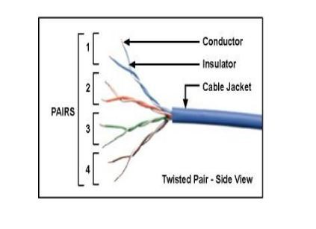

Figure 14- Twisted pair cable

**Shielded twisted pair** (STP) cables; it's like UTP but there is more shielding and is available in three different configurations, these are:

* Each pair of wires is individually shielded with a foil
* There is a foil or braid shield inside the jacket covering all wires (as a group)
* There is a shield around each individual pair, as well as around the entire group of wires (referred to as double shield twisted pair)

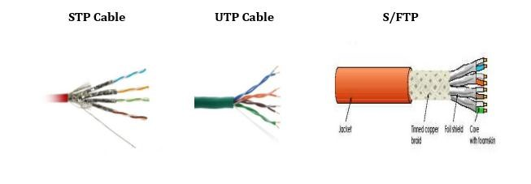

Figure 15- Shielded twisted pair cables

This type of cable is implemented in environments with lots of potential interference, noise or extremely sensitive environments that may be susceptible to the electrical current. It is also used to extend the maximum distance of the cables or cover long distances.

**Coaxial cables.** Coaxial lines confine the electromagnetic wave to area inside the cable, between the center conductor and the shield. Energy transmission in the line occurs totally through the dielectric inside the cable between the conductors

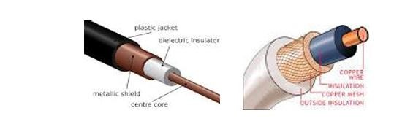

Figure 16- Coaxial cable

**Patch cables.** A patch cable is an electrical or optical cable used to connect one electronic or optical device to another for signal routing. Devices of different types (e.g. a switch connected to a computer, or a switch connected to a router).

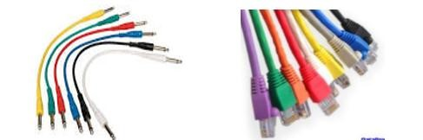

Figure 17- Patch cables.

**Image of Straight through Wiring**

This cables are used to connect different devices.

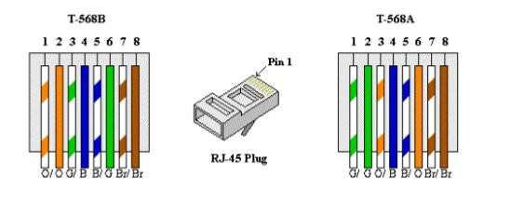

Figure 18- Straight through termination

**Image of Crossed wiring**

This is used to connect similar devices.

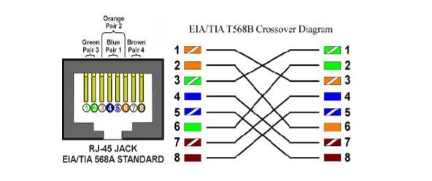

Figure 19- Cross over termination

1. T-568 B T-568 A
2. – White orange 1 – White green
3. – Orange 2 – Green
4. – White green 3 – White brown
5. – Blue 4 – Blue
6. – White blue 5 – White blue
7. – Green 6 – Orange
8. – White brown 7 – White brown
9. – Brown 8 – Brown

The RJ45 plug is where the strands are inserted and a plug crimping tool is used to firmly hold the strands and plug connectors together

**Fibre optic cable.**

Consists of a center glass core surrounded by several layers of protective materials. Made of pin glass strands that transmit signals. It’s a fragile cable and it transmits speed is in Tera and Laser. It transmits light rather than electronic signals eliminating the problem of electrical interference. This makes it ideal for certain environments that contain a large amount of electrical interference. It has the ability to transmit signals over much longer distances than coaxial and twisted pair. It also has the capability to carry information at vastly greater speeds. This capacity broadens communication possibilities to include services such as video conferencing and interactive services. There are two common types of fibre cables; **single mode** and **multimode**.

In comparison, a multimode cable has a larger diameter; however, both cables provide high bandwidth at high speeds (10GBps). Single mode can provide more distance but is more expensive. Single mode cables are yellow in color and travel for 25km and they are small size of 9-11 / 125e and multimode cables are orange in color and travel for 5km and has a size of 50-60e.

In this case, the exiting network using CAT5-UTP was upgraded to CAT6-UTP and to CAT7-UTP and a fibre optic cable was used to connect to the sub network.

**Compositions of an optic fibre**

1. Core –inner most part made in clear glass
2. Cladding
3. Core insulation (PVC)
4. Tube (outer PVC)
5. Yan
6. Strands.

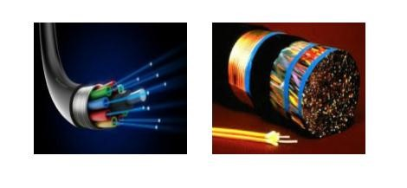

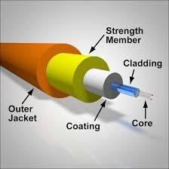

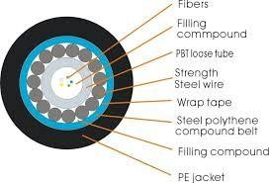

Figure 20- Optic Fibres.

**color coding of optic fibres.**

Strand 1 -Blue

Strand 2 -Orange

Strand 3 -Green

Strand 4 -Brown

Strand 5 -Slate / Grey

Strand 6 –White

Knowing the color of the strands is very important and makes troubleshooting easy

1. **Design implementation.**

The network was physically built according to the design plan and it should be done accurately with precautions to minimize signal loss. It involved activities such as laying cables and their pathways, installation of rack cabinets, termination of patch panels, fibre optic connectors, interface sockets and verification. The precautions taken included the following:

Cable pathways should not be placed on lighting fixtures or hot pipes as they can be damaged and cables should never be bent at an angle of 900 instead implement a flexible conduit for such an angle.

Avoid pair spread when terminating UTP pairs; tension should be used to avoid pair separation because untwisting more cable than is necessary will increase the amount of crosstalk and degrade overall network performance.

During terminating a patch panel; the RJ-45 jack was wired according to either T568B. A punch down tool was used to push the wires into the connector. One precaution taken into consideration was that; the wires should be matched up to the appropriate insulation displacement connector (IDC) by colour before punching them down. The punch down tool cuts off any excess wire. It is also used to terminate wall jacks.

A terminated cable was then verified to prove whether it operated correctly and met connectivity standards. This was usually done through a series of tests. The first test is a visual inspection, which verifies that all wires are connected according to T568A or B.

**TABLE SHOWING TOOLS USED IN CABLE TERMINATION**

|  |  |  |
| --- | --- | --- |
| **Muiltmetre tool** | **Crimping tool** | **Striper tool** |
| G:\intern photos\IMG_20180608_101411.jpg |  |  |

Table 5- Cable termination tools.

1. **Documentation.**

This is the final stage in building a network. It requires to clearly and legibly writing down every single step made in implementing the design. This is good for future reference and faster network trouble shooting.

**NETWORK CONFIGURATION USING A SIMULATOR.**

I was introduced to network configuration using packet tracer by Eng. Rasheed and had an opportunity to learn quite a number of new and interesting things.

**Packet Tracer** is a software or tool that enables a user to configure or simulate network devices like laptops, routers, switches etc. The general name given to laptops or PCs on a network is HOST**.**

**Hubs** are also network devices that can be included in a network and it is a non-authentic end device which makes most engineers prefer a **switch**, which is authentic and verifies a packet before directing it to and end device. Network configuration is categorized into wo types;

Static configuration

Here an engineer installs the network and then configures it but only the router and its defaults are configured as,

Router (config) # ip def. 10.0.0.2 where this represents the class the network created falls.

**Dynamic configuration**

This involves configuring the routes in which data is to pass, network ip addresses in the different modes of configuration.

Router (config) # route rip

Router (config) # 192.168.3.0

I was tasked to create a star topology of four laptops, three PCs, one switch. I had to name all the network devices right from the switch down to the laptops and PCs after connecting them with the right cable, there after I had to assign the switch a password and perform other configuration like line vty, creating a vlan, assigning a default IP and finally checking for packet movement from one device to the other. This assignment was given to me by Eng. Rasheed who did the timing by himself and I had ten minutes to do all these, in the end I managed to score 72% after being marked by Mercy Abwot, my other colleague under engineer’s guidance. us and we created a star topology and see the difference between hub and a switch.

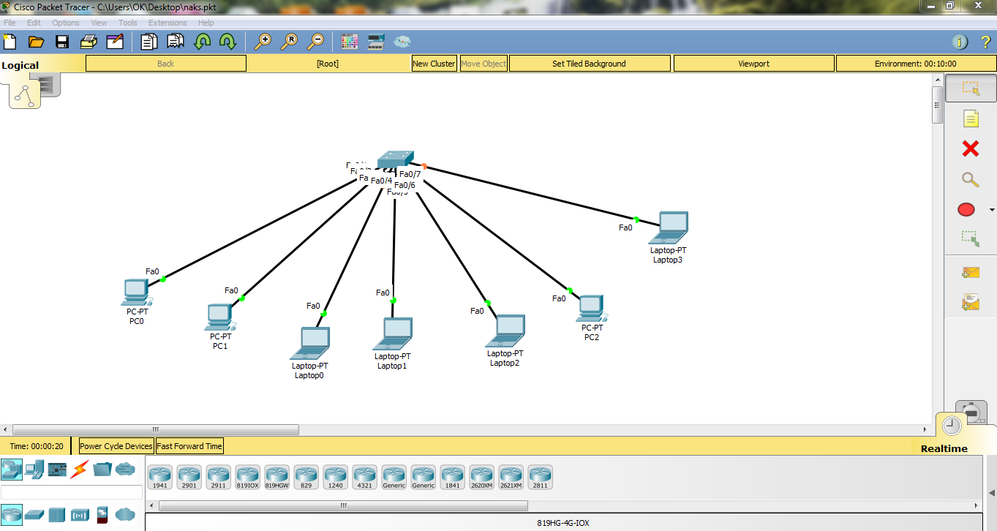

Figure 21- Packet Tracer configuration

### **2.2.2 WIRELESS NETWORKS**

Wireless networks do not necessarily involve cable termination or laying down of cables. Communication is in form of wireless signals and it involves quite a number of devices such as antennas, routers, repeaters, communication dish plates, modems and so many other communication devices. Wireless signals are in variety of forms which include;

**Infrared signals**: These cover or travel in very short distances.

**Radio signals**: They cover a moderate distance approximately 30 meters.

**Micro wave Signals**: These cover very long distances are basically used by radio stations during broadcasts.

#### **2.2.2.1 WIRELESS MODES.**

**Access point**.

Here your network is configured to a central access point for all the roaming devices on the network. For instance, two computers can only communicate to each other through the configured access point. These access points have standards; therefore, one should be aware of the standards since different device standards do not connect. A device with a standard in the n series does not connect to that of standard g.

**Illustration**

To PC2 From PC1

**Access**

**point**

**PC2**

**PC1**

From PC2 To PC1

Figure 22- Access point layout.

**Bridge.**

This is a connection between two different LAN networks wirelessly and a point to point wireless connection is made.

**Illustration.**

Block B

LAN

Block A

LAN

Bridge

Figure 23- Bridge layout.

**Wide Distribution System. (WDS)**

This can serve as a point to point connection or as a point to many. There is an administrator that is accessed by all other departments and this is configured by picking the Mac address of the directional bridges at the other departments (A, B, C) and putting them in the admin.

**Illustration.**

B

ADMIN

A

C

Directional

antenna

Directional

Antenna

Figure 24- WDS setup.

**Assignment.**

Having gone through the wireless modes of a network, I was tasked by Eng. Sewamkambo to configure an access point that is to say a D-Link router where I had to Google its default IP address using its model name which was known. I then set my machine a default IP address in the same network later on then browsed the router using Google chrome on my PC, the router interface was then visible and started the configuration by assigning the network name, password or security, mode of access, number of users and so on, this then turned out successful since I was able to access the set Wi-Fi using my mobile phone and was able to login the network

## 2.3 CSD UPS DEPARTMENT.

Was introduced to UPS in the second week on the 11h June 2018. A UPS is used especially where unexpected current out breaks may occur; it provides emergency power to a load when the input power fails. The IEC (International Electro Technical Commission) established three standards of UPS and methods used to measure their performance.

UPS uses batteries to keep power on for given period of time thus the higher the load the less the time that the ups will be able to be on hence all backups must be done in the given time since the ups backs up for short time until the generator kicks.

### **2.3.1 UPS TOPOLOGY.**

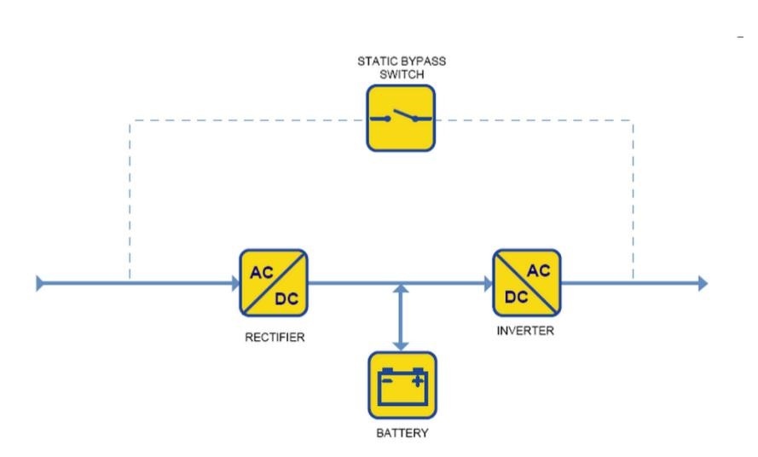

Figure 25- UPS topology

### **2.3.2 UPS TYPES.**

There are basically three types of UPS:

* Passive Stand by
* Line-interactive
* Double conversion on line

These UPS types can be installed either as a **stand-alone** or **parallel** UPS installation.

Stand-alone installation is where a single UPS is installed to support all the load while parallel is where a number of UPS are installed in parallel to support a given set of load and it is further broken down into:

**Parallel capacity:** Here the load is broken down equally and loaded onto the installed UPS equally.

**Parallel Redundancy:** Here one of the installed UPS is meant to support all the load while the other the other is on standby; in case the first UPS fails, the other takes up the load that was initially supported by the first UPS.

When installing a UPS, it can either be connected to a stabilizer or not. The stabilizer collects the AC from poer source and supplies the UPS wth clean power. Below is a structure of a stabilizer;

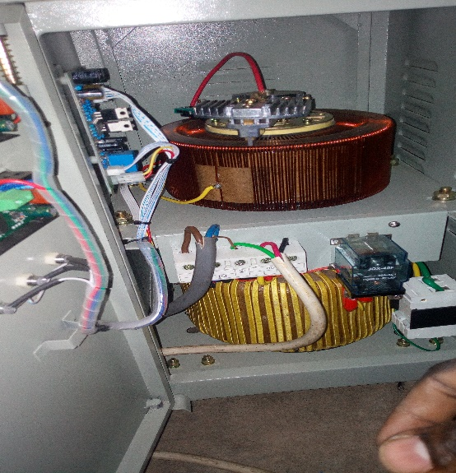

Figure 26- Stabilizer.

At KCB bank, as a group under the instruction of Eng. Felix, we managed to uninstall their UPS since the company was changing location of operation, this UPS system was intended to be transported to their branch in Lira, there it needed to first be assembled and tested in NCR workshop before being transported to Lira. Below are the UPS set before and after installation.

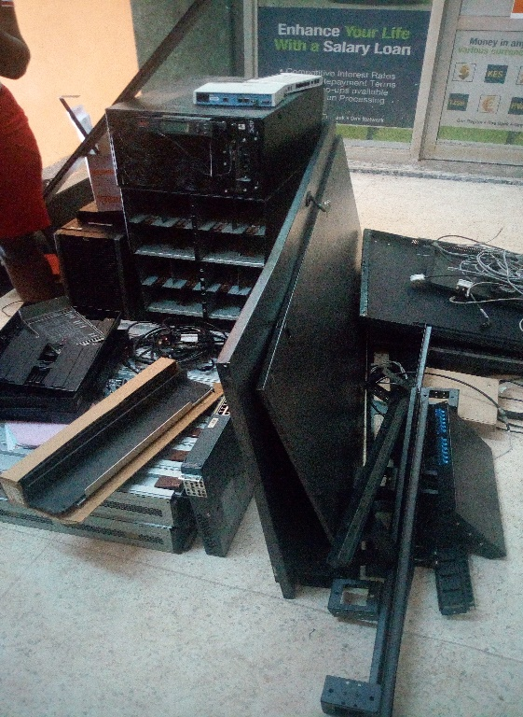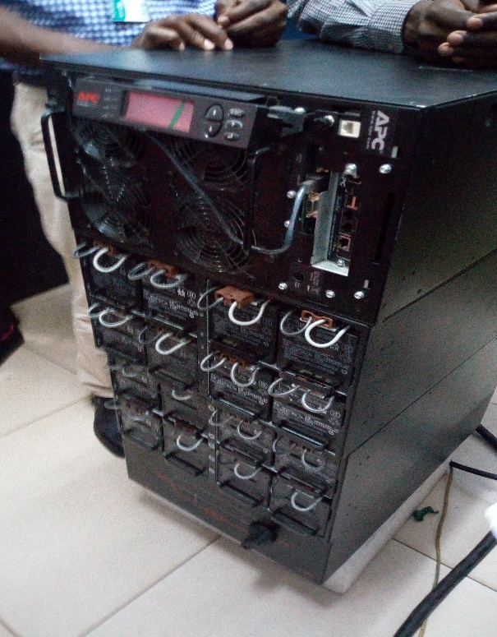

Figure 27- Before and after UPS installation

### **2.3.3 UPS BYPASS MODE.**

A UPS is usually put in bypass mode when one is going to do a preventive maintenance service on it or doing a UPS repair. There are two bypass modes:

**Internal bypass:** this is done within the UPS itself, if it senses low voltage, it takes over and when power goes off, it goes off as well. It is safe since it provides the load with clean power.

**External bypass:** This is when the UPS has totally failed and does not do a backup. In other words, it is the protection of the load or machines when you want to do a service. UPS is equipped with a static bypass i.e. static switch that can be used to transfer the load without a break to the AC bypass

**STEPS TO SAFELY ACHIEVE BYPASS**

* First turn off the UPS.
* Trigger the bypass mode on.
* Turn off the UPS output.
* Turn off the UPS.
* Turn off the service bypass switch off finally

**UPS bypass structure.**

**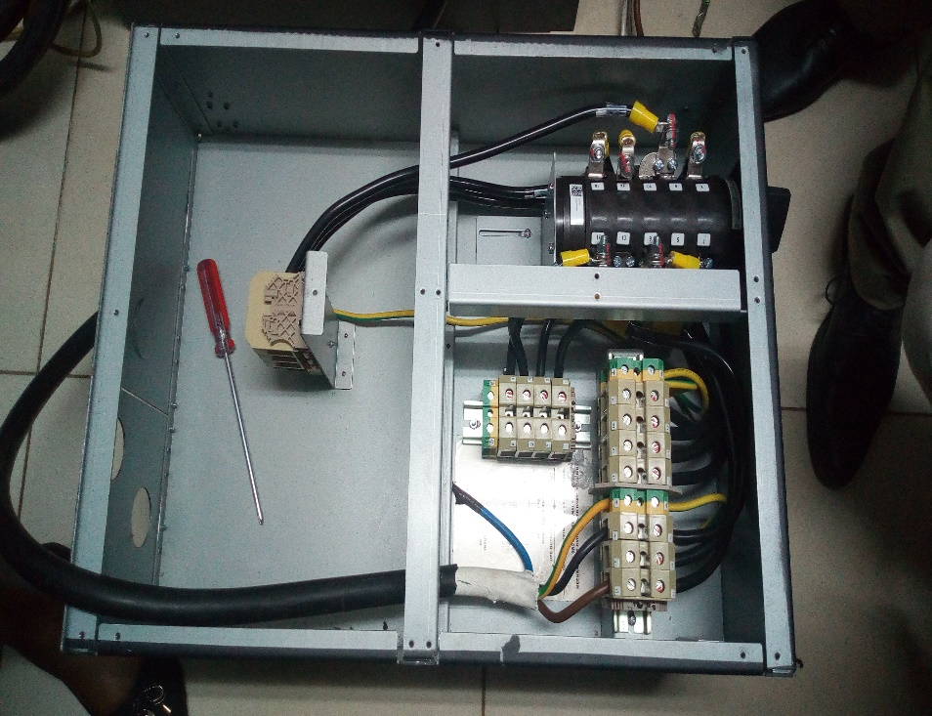**

Figure 28- UPS Bypass structure.

.

## 2.4 ESD DEPARTMENT.

Under this department, the company is able to perform computing solutions to a number of clients and the company has quite a number of running projects in field that its apparently working on. We were assigned a simple project of working on a fully dead server from identifying what is missing, looking for the missing parts to repair and installation of windows server 2012 on the server. First and foremost a number of engineers took us through under this department as follows

### **2.4.1 SERVERS**

This was introduced by Eng. Michael who started by providing us with background information on servers, their operability, functions and challenges faced. He described us what a server is its major difference with normal PCs and below is a pic of how its internal looks are;

**Structure of a server (internal).**

**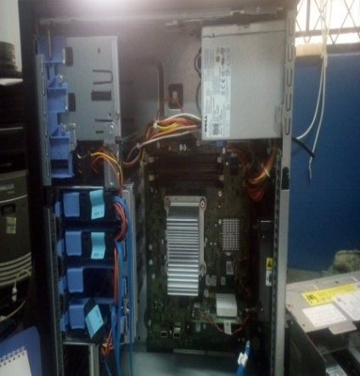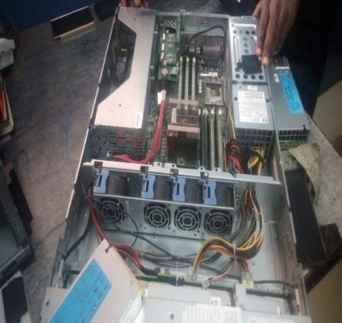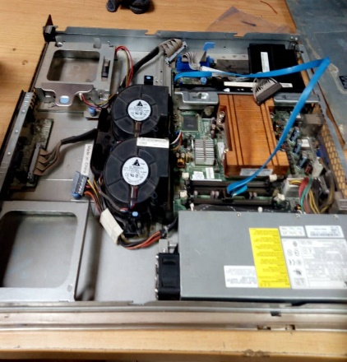**

Figure 29- Internal structure of a server

**Difference between a server and a computer**

* Servers don’t shut down while computers shut down after use.
* A computer is a collection of hardware while a server can either be hardware or software.
* A single computer can host multiple servers at the same time but with a limited number of users.
* Most serious businesses utilized high end servers with hardware that are not usually found in PC to cope with great demands.
* Servers are kept running for weeks or months at a time and require redundant systems to cope with failure.

### **2.4.2 NOTIFIER APP**

Through the interaction with quite a number of engineers in the company, came across Eng. Elvis who was working on an e-based system, got challenged to come up with a solution that would help the company engineers perform their tasks in time to avoid complaints from customers, this was a big challenge for the company since many engineers would come the next day with un accomplished tasks of yesterday and this brought a lot of tension in the early morning meeting. Through help from Elvis who helped install android studio and all its gradles, started working on my system which will help engineers to schedule the tasks to be performed that day with the location, they would then receive a notification reminding them of the undone tasks , the android based app will use Google maps to help create a geofence. A geofence is a virtual perimeter within the actual geographical location. The app notifies an engineer of when they enter the geofence.

**Objectives**

* To provide the engineers with a platform to schedule their tasks
* To provide users with a platform to identify locations where the tasks are to performed
* To enable alarm that will remind users of their tasks

**Goals**

* To reduce on the tendency of failure of engineers to attend to certain tasks
* To ensure timely performance of crucial tasks.

**Implementations:** Below are some of the interfaces of the mobile application that will act as a

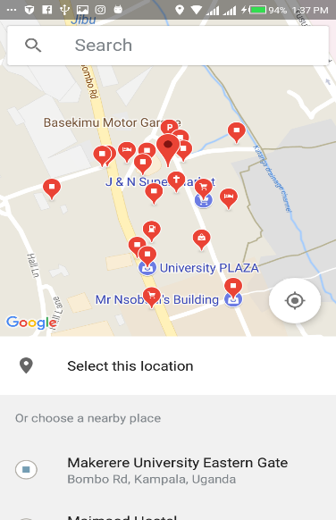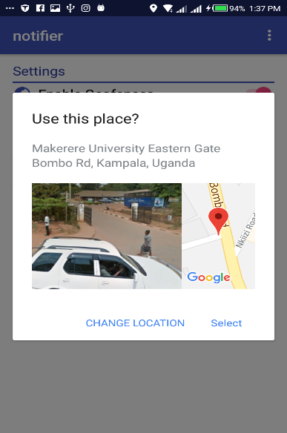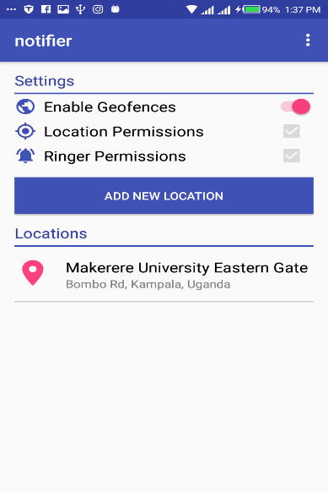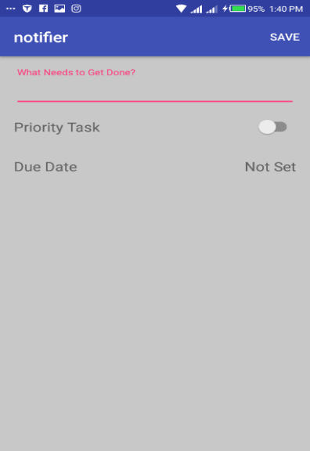task scheduler and notifier to engineers at NCR.

# 

Figure 30- Interfaces of Task Notifier App.

# CHAPTER THREE.

# 3.0 DISCUSSION OF EXPERIENCES

## 3.1 Knowledge and skills gained

By the end of my training period, I had acquired a number of new skills and gained knowledge about the following;

* Soldering and unsoldering simple components of an electric circuit like VGA cables using the soldering gun, solder wire
* How to service equipment like the UPS, printers and pcs using equipment like the blower, pledge, shinex, brushes and towels
* How to use the multimeter when testing for continuity, voltage and current.
* Interpersonal skills, good conduct and better communication skills since we had to interact with a great deal of people when out in field
* Disassembling and assembling UPS machines, servers using stars and spanners
* Disassembling and assembling personal computers
* Setting up point of sale work stations, biometric device and networking cables
* How an ATM machine operates and its layout.
* Configuring several electronic devices like routers, servers, biometric device.

## 3.2 Most interesting experiences.

I had quite a number of interesting experiences, a few of which include;

1. Carrying out a network survey at Quality Chemicals Industries, Luzira. The company needed to set a connection between their two factories to communicate as though they are on the same LAN network.
2. Carrying out Preventive Maintenance Service at ICEA company, this was more of an eye opener since it was my first service with all the trust granted to me by all the engineers we had gone with.
3. Setting up a network at Makerere CIT Block A, this was done in their conference room on level 2 right from survey to building of a rack cabinet and network testing.

## 3.3 Relatedness of University’s taught programs to field of work.

Networking, communication skills, professional ethics and system security are element of the academic work that has been realized during training.

Networking has been handled practically rather than theoretical, interpersonal and communication skills; have been developed during this training and security of information systems has been implemented in many organizations who deal with sensitive information such as banks. Also the discipline of working in a professional organization has been experienced.

## 3.4 Challenges faced and how managed.

Punctuality. Arrival time at NCR is too early, i.e. before 8am yet I stay far from town but I did my best to cope up and manage time by waking up as early as 5am.

At SCI each staff in the Workshop, UPS and Networking must possess his or her own tools to use in the workshop, the company provide a few and for only the authorized ones. I had to buy my tools.

Facilitating myself was quite a huge challenge since the University did not provide us with facilitation fees this time round, I had to look for my own transport, and feeding fees, and at times the company transported us to field but coming back after work is done, one had to pay transport.

Confronting and working with a group of people I never meet was really challenging as well as getting signatures for most supervisors to sign on the daily activity record was very hard, but later after understanding them I was able to cooperate and work with them.

## 3.5 Benefits derived from field attachment.

This training has offered me practical skills and experience in fields such as; networks, servers and computer hardware, customer care, electronics repair, trouble shooting, service and maintenance skills, which has broadened my knowledge as an IT professional.

The social status has been improved through being exposed to the work place, cooperating with colleagues and being able to interact with people of high profile hence building confidence and integrity.

It has also presented me with opportunities to interact with many different organizations that could be my future employers.

Interacting with other professional in the different fields has equipped with me a code of conduct in the work place, for example; managing time, team work and problem solving skills.

## 3.6 Career motivation.

I was exposed to hands on training where by everything that was done during training was practical. All the activities carried out were done practically by me and the help of my colleagues because at times we worked as a team. This has really boosted my interest in the field of IT because I now have the confidence to work and handle IT equipment or devices thus a huge boost of my career.

# CHAPTER FOUR

## 4.1 CONCLUSIONS.

This attachment training is worth my credit since it exposed me to a practical world. It helped me interact with various individuals in the organization. These individuals are all of different personalities and as a result I was able to respond to each one of them accordingly. It also exposed me to a real working environment. The attachment also helped me discover my strengths and weakness as I struggle to make it in the industry I was able to learn the ups and downs encountered in the field and how people and governments work tirelessly to ensure the smooth running of things. This was a real eye opener and it will go a long way in shaping me as a future professional in the field.

This training has been a success and has equipped me with good knowledge in many aspects in the IT field and the work place. Grate thanks to all the NCR team, fellow trainees, and the University which recommended this training as a must do requirement.

God bless you all.

## 4.2 RECOMMENDATIONS.

**To Service & Computer Industries Limited.**

* To try and give students more opportunities for practical hands on expertise to students who wish to return to the company for more training after their studies.

**To the faculty.**

* I recommend that the faculty should continue to enforce students to undergo internship in order to relate their theory with practical experience.
* I also recommend that the faculty should allocate more time to practical sessions than theoretical lectures so that the students can learn more practical skills.

**To the students**

* I recommend that students take the internship period serious for one can never know what may become of the time at internship.
* Also students should be cooperative and involve in teamwork since it’s the only way to excel in any IT field. Since we all learn from one other and one cannot know everything.

**To the supervisors**

* I appreciate my supervisors **Engineer Miiro William** and **Dr. Agnes Nakawawa** who found time out of their schedules to assist me in gaining the necessary skills and would like to recommend that you follow up best performing students sent to your organization and get in contact with students as early as the first month, respectively.

## 4.3 APPENDICES.

# G:\intern photos\IMG_20180614_110549.jpgG:\intern photos\IMG_20180618_143057.jpgG:\intern photos\IMG_20180626_120344.jpg

Figure 31- Cable laying at Makerere, card printer, industrial cable.